Process Concept: Process Concept, Process Scheduling, Operations on  Processes, Inter-process Communication. | 3.1 Process Concept  3.2 Process Scheduling  3.3 Operations on Processes  3.4 Interprocess Communication

Chapter 3
3.1Process Concept
    - The Process
    - Process State
    - Process Control Block
    - Threads
  - Process Scheduling
    - Scheduling Queues
    - Schedulers
    - Context Switch
  - Operations on Processes
    - Process Creation
    - Process Termination
3.4 Interprocess Communication
3.4.1 Shared-Memory Systems
Producer–consumer problem
3.4.2 Message-Passing Systems
3.4.2.1 Naming
3.4.2.2 Synchronization
3.4.2.3 Buffering

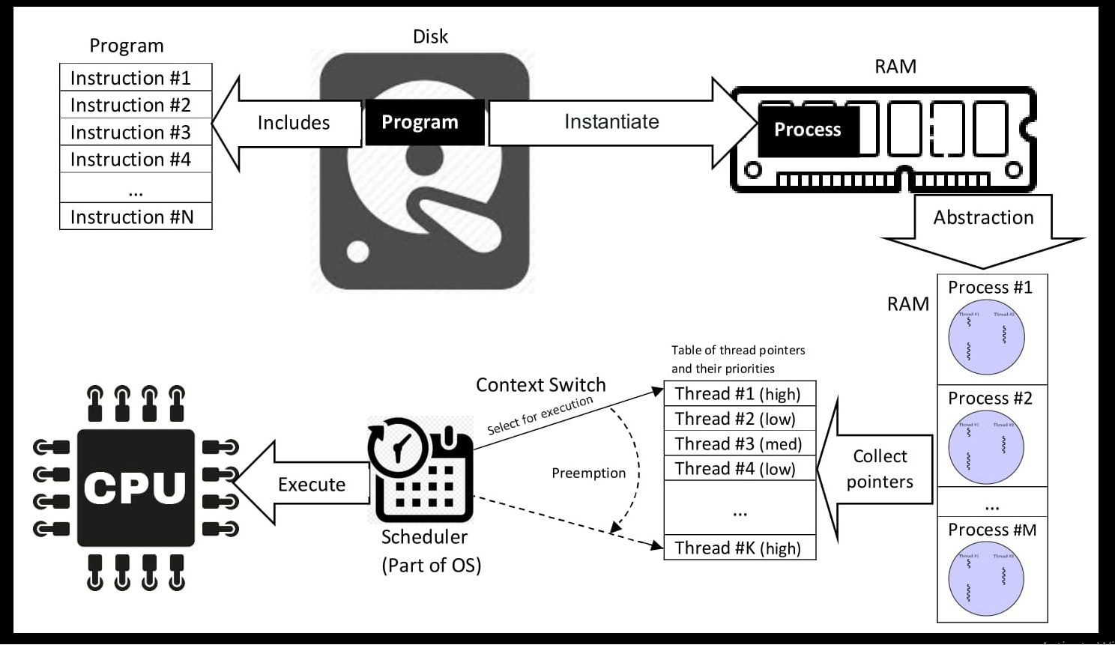

  - Process Concept:
In operating systems, all CPU activities—whether jobs in batch systems, tasks in time- shared systems, or programs in single-user systems like memory management-are collectively referred to as processes. While the term process is now preferred, job is often used interchangeably due to its historical relevance in operating system terminology, such as in job scheduling.
    - The Process
A process is a program in execution, comprising more than just program code (text section).

Components of a Process:
      - Text Section: Contains the program code.
      - Program Counter: Represents the current activity by specifying the next instruction.
      - Processor Registers: Store the current state of the CPU.
      - Process Stack: Holds temporary data like function parameters, return addresses, and local variables.
      - Data Section: Contains global variables.
      - Heap: Memory dynamically allocated during process runtime.
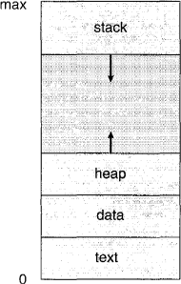

Figure 3.1 Process in memory.

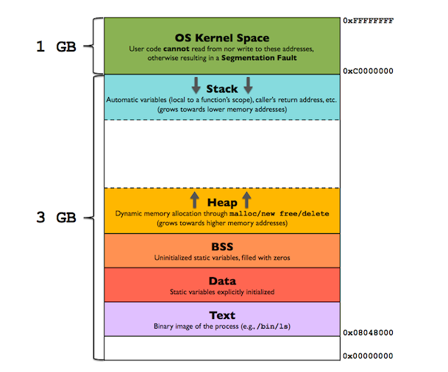

Process Component | Where It Exists | Explanation
Text Section (Program Code) | RAM (loaded from Hard Disk) | The compiled program stored on disk is loaded into RAM when the program starts.
Program Counter | CPU Register (managed by kernel during context switch) | A special CPU register pointing to the next instruction to execute.
Processor Registers | CPU Registers | Temporary storage inside the CPU for executing instructions.
Process Stack | RAM (Process memory space) | Stores function parameters, return addresses, and local variables during execution.
Data Section | RAM (Process memory space) | Stores global and static variables.
Heap | RAM (Process memory space) | Memory allocated dynamically during runtime using malloc(), new, etc.

Process Component | Corresponding Section
Text Section | Text
Program Counter | Text
Processor Registers | Text
Process Stack | Stack
Data Section | Data
Heap | Heap

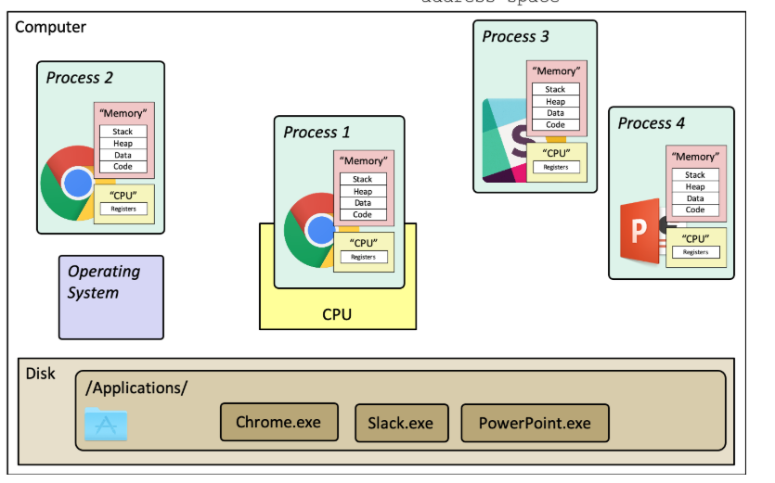

A diagram illustrating the high-level idea of a process. Each process has it's own "memory" and "CPU", which in reality are virtualized shared resources. A program (like Chrome.exe) can have multiple running instances (processes). Note that the operating system is not a process—it's just a block of code.
Program is a passive entity (e.g., an executable file), whereas a process is an active entity with allocated resources and execution flow. A program becomes a process when loaded into memory, initiated by actions like double-clicking an icon or entering its name in the command line.
Multiple processes can run the same program but are considered separate execution sequences. For example
      - Several users running the mail program.
      - A single user opening multiple instances of a web browser.
Multiple processes can originate from the same program but are treated as distinct execution sequences, with shared text sections but independent data, stack, and heap sections. For example, multiple users can run separate instances of the same program, and processes can spawn others during execution.
    - Process State
A process transitions through several states during execution, defined by its current activity:

      - New: The process is being created.
      - Running: Instructions are being executed.
      - Waiting: The process is waiting for an event (e.g., I/O completion).
      - Ready: The process is waiting to be assigned to a processor.
      - Terminated: The process has completed execution.
These states are universal but may vary in naming across operating systems. Only one process can run on a processor at a time, while many others may be ready or waiting. The transitions between these states are represented in a state diagram.
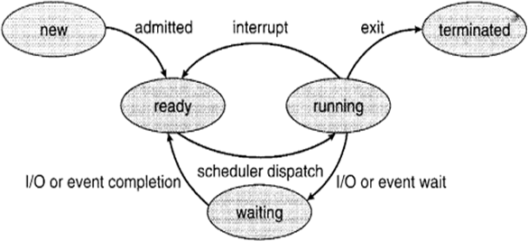

Figure 3.2 Diagram of process state.

A process can move from the Running state either when the operating system preempts it due to an interrupt or time-slice expiration, or when it requests an I/O operation and enters the Waiting state until the event completes

When Running → Ready (Interrupt / Preemption) Happens
This generally happens when the CPU scheduler decides another process should run.
Situation | What Happens
Time slice expires in Round Robin | OS preempts the running process and puts it back in the ready queue
Higher-priority process becomes ready | Current process is interrupted and moved to ready
Hardware interrupt requiring rescheduling | CPU switches to another process

When Running → Waiting Happens
This happens when the process itself cannot continue without some external event.
Situation | What Happens
Process requests disk I/O | Moves to waiting until disk operation completes
Waiting for keyboard input | Process waits for user input
Waiting for network response | Process waits for data from network
Synchronization (mutex/semaphore) | Process waits for a resource

    - Process Control Block
The Process Control Block (PCB), also known as the task control block, represents a process in the operating system and stores process-specific information, including:
      - Process State: Current state (e.g., new, ready, running, waiting, or terminated).
      - Program Counter: Address of the next instruction to execute.
      - CPU Registers: Includes accumulators, index registers, stack pointers, and other state information saved during interrupts.
      - CPU Scheduling Information: Contains process priority, scheduling queue pointers, and parameters.
      - Memory Management Information: Includes base/limit registers, page tables, or segment tables.

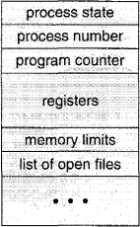

Figure 3.3 Process control block (PCB)
      - Accounting Information: Tracks CPU usage, time limits, process IDs, and other resource usage metrics.
      - I/O Status Information: Lists allocated I/O devices and open files. The PCB acts as a repository for all data needed to manage a specific process.

PCB Field | Purpose | Sample Example
Process ID (PID) | Unique identifier for each process | PID = 1042
Process State | Current state of the process | Running / Ready / Waiting
Program Counter | Address of the next instruction to execute | 0x00401520
CPU Registers | Stores CPU state during execution | AX = 5, BX = 10, SP = 0x7fff
Memory Management Information | Information about memory allocation (page table, base/limit registers) | Page table base = 0x1000
CPU Scheduling Information | Scheduling parameters such as priority and queue pointers | Priority = 3
I/O Status Information | List of open files and allocated devices | File descriptor = 3 (test.txt)
Accounting Information | Tracks resource usage and process ownership | CPU time used = 2.3 sec

A Process Control Block (PCB) is a data structure used by an operating system to store all the information and execution context needed to manage a specific process. It acts as a digital "identity card" for each running process,
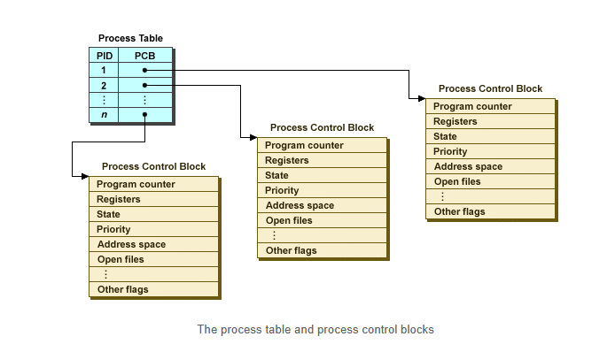

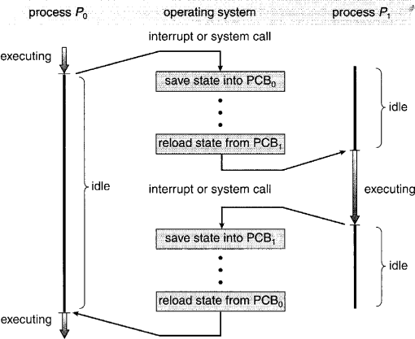

Figure 3.4 Diagram showing CPU switch from process to process.

    - Threads
The traditional process model assumes a single thread of execution, where a process performs one task at a time. For example, a word processor allows typing or running a spell checker, but not both simultaneously. Modern operating systems enhance this concept by enabling multiple threads within a process, allowing concurrent execution of tasks.
- A thread is a single sequence stream within a process and is called a lightweight process because it is smaller and faster. It allows multiple tasks to run simultaneously, improving program efficiency.
- In single-core systems, it creates an illusion of parallelism; in multi-core systems, threads can execute truly in parallel across different cores.
- Each thread has its own program counter, register set, and stack space.
- Threads share code, data, and operating system resources within the same process.

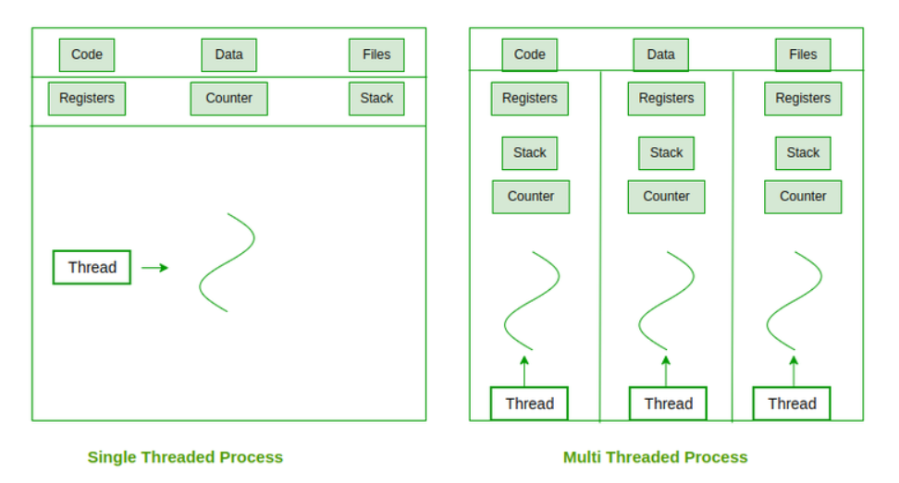

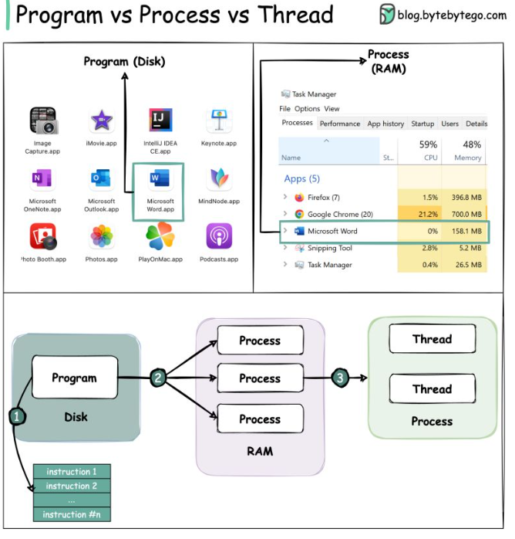

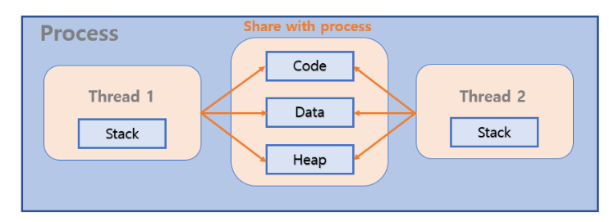

PCB manages the process, TCB manages the thread

PCB (Process)

↓

Shared Resources:

- Code

- Data

- Heap

Threads:

- T1 → TCB1 (own stack)

- T2 → TCB2 (own stack)

- T3 → TCB3 (own stack)

  - Process Scheduling:
The goal of multiprogramming is to maximize CPU utilization by ensuring a process is always running. Time sharing aims to switch the CPU rapidly between processes, allowing user interaction with running programs. The process scheduler selects a process for execution from the available ones. On a single-processor system, only one process runs at a time, while others wait for the CPU to become available.
    - Scheduling Queues
Processes in the system are organized into queues:
      - The job queue holds all processes in the system.
      - The ready queue, stored as a linked list, contains processes in main memory that are ready to execute. It has a header pointing to the first and last PCB, with each PCB linking to the next in the queue.
      - Additional queues manage processes waiting for specific events, such as I/O completion, or those interrupted or terminated after CPU execution.
A process contains multiple threads that share code, data, and heap memory, while each thread maintains its own stack. For example, in a web browser, multiple threads handle tasks like loading pages and playing media simultaneously. This is similar to chefs working in a kitchen where they share ingredients but perform different tasks independently.

PROCESS REPRESENTATION IN LINUX:
In Linux, the process control block is represented by the task struct C structure. It contains essential information about a process, including its state, scheduling and memory management details, open files, and pointers to its parent and children processes.
pid_t pid; /* process identifier */ long state ; / * stat e of the process */
unsigned int time..slice / * scheduling information */ struct files_struct *files; / * list of open file s */
struct mm_struct *mm; /* address space of this process */

In Linux, a process's state is stored in the long state field within the task_struct. All active processes are organized in a doubly linked list of task_struct, and the kernel uses a pointer current to track the process currently executing.
To change the state of the currently running process, the kernel updates the state field in its task_structusing:
current->state = new_state;, where current points to the executing process

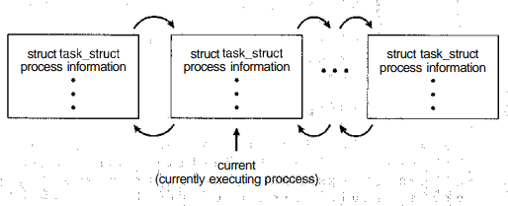

Figure 3.5 Active processes in Linux.
When a process requests I/O, like accessing a disk, it may need to wait if the device is busy. Each device has its own device queue for processes waiting for access.
Queueing diagrams represent process scheduling, with rectangular boxes as queues (e.g., ready and device queues) and circles as resources. Arrows show process flow.
A new process enters the ready queue and waits to be dispatched. Once executing, it may:
- Issue an I/O request and move to a device queue.
- Create a subprocess and wait for its termination.
- Be interrupted and return to the ready queue.
The process cycles through states until termination, after which it is removed from all queues and its PCB and resources are freed.
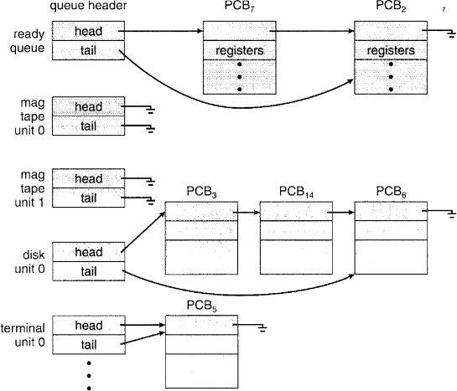

Figure 3.6 The ready queue and various I/O device queues

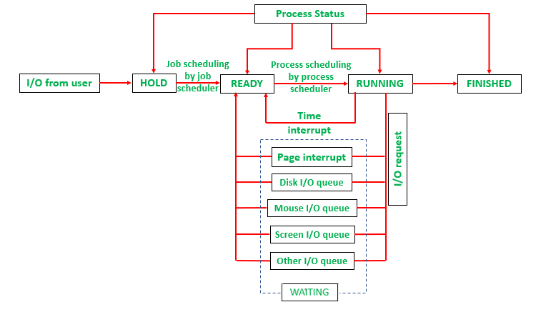

    - Schedulers: Throughout its lifetime, a process moves between scheduling queues, and the scheduler selects processes for execution.
      - Long-term scheduler (job scheduler):
        - Selects processes from the pool of jobs on storage and loads them into memory.
        - Executes infrequently and controls the degree of multiprogramming.
        - Balances I/O-bound (spend more time on I/O) and CPU-bound (spend more time on computation) processes for system efficiency.
      - Short-term scheduler (CPU scheduler):
        - Selects processes from the ready queue for CPU allocation.
        - Executes frequently, often every 100 ms, requiring high speed to avoid CPU time wastage.
      - Medium-term scheduler:
        - Used in time-sharing systems to optimize performance.
        - Temporarily removes processes from memory (swapping) to reduce multiprogramming.
        - Reintroduces processes later, resuming execution from where they stopped.
        - Helps improve process mix or manage memory overcommitment.
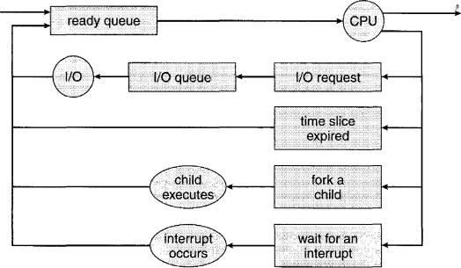

Figure 3.7 Queueing-diagram representation of process scheduling.

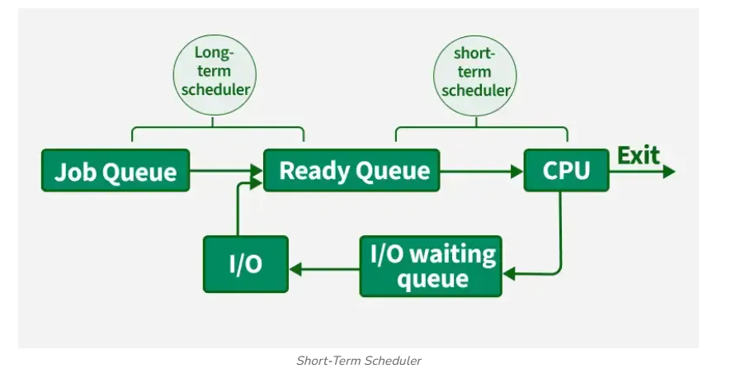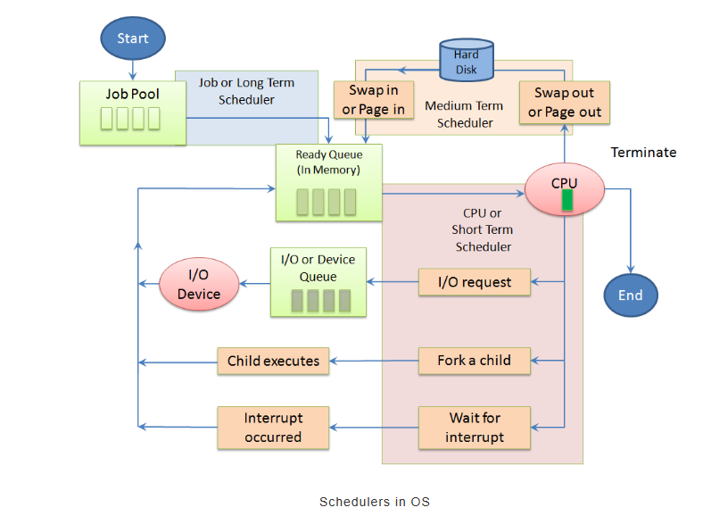

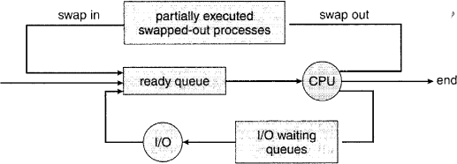

Figure 3.8 Addition of medium-term scheduling to the queueing diagram.
A balanced mix of I/O-bound and CPU-bound processes ensures optimal system performance by keeping both the CPU and I/O devices utilized effectively.
In some systems, like UNIX and Windows, the long-term scheduler may be minimal or absent, as new processes are directly handled by the short-term scheduler. System stability in such cases relies on physical limits (e.g., number of terminals) or user behavior.
    - Context Switch
Interrupts prompt the operating system to pause the current process, save its context (CPU registers, process state, memory info), and switch to a kernel routine. This process, called a context switch, involves:
- State Save: Saving the current process's context in its PCB.
- State Restore: Loading the context of the next scheduled process.
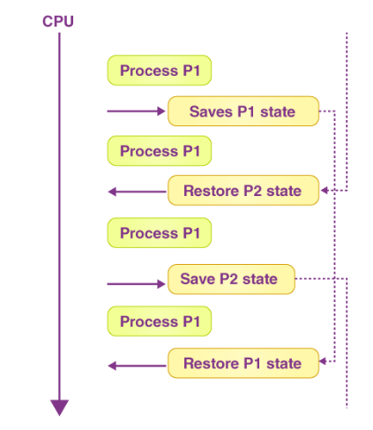

Key points about context switching:
  - It is overhead with no useful work done during the switch.
  - Speed depends on hardware, memory, and OS complexity.
  - Advanced systems may need additional work, like switching memory address spaces.
  - Some processors, like Sun UltraSPARC, optimize this with multiple register sets, reducing overhead.
  - Operations on Processes:
Most systems allow concurrent process execution and dynamic creation and termination of processes. Therefore, these systems need mechanisms for process creation and termination. This section covers the process creation mechanisms, with examples from UNIX and Windows systems.

    - Process Creation Parent and Child Processes:
      - A process can create several new processes during its execution using the create- process system call.
      - The creating process is called the parent process, and the new processes are called

child processes.
      - Child processes can create their own child processes, forming a tree of processes. Process Identifiers (pid): Processes are uniquely identified by a process identifier (pid), typically an integer.
Process Tree Example: Example from Solaris OS:
        - The sched process (pid: 0) is at the root of the process tree.
        - The sched process creates processes like pageout (memory management) and
fsflush (file system management).
        - The init process (root parent of all user processes) spawns processes like inetd
(networking services) and dtlogin (user login screen).
        - User login leads to the creation of child processes such as Xsession, csh, and user commands (e.g., ls, cat).

Viewing Processes:
In UNIX, the ps command is used to list active processes.
        - Example: ps -e l provides detailed information about all active processes.
        - A process tree can be constructed by tracing parent processes recursively to the

init process. Resource Allocation:
A process requires resources (CPU time, memory, files, I/O devices) to perform tasks. When creating a subprocess:
        - Resources can be obtained directly from the operating system.
        - Alternatively, the parent process may share or partition its resources among its children.
        - Restricting resources helps prevent system overload due to excessive subprocess creation.

Passing Initialization Data:
A parent process can pass initialization data (e.g., file names, output devices) to child processes.

        - Example: A process displaying img.jpg on a terminal might receive the file name and output device from its parent.
        - The process may use this data to open the file and transfer its contents to the specified device.

Resource Sharing:
      - Some operating systems allow sharing of resources (e.g., memory, open files) among parent and child processes.
      - This enables efficient data transfer and resource usage between processes.
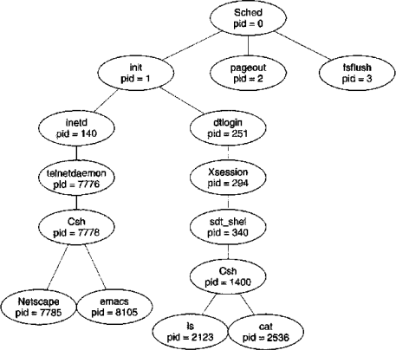

Figure 3.9 A tree of processes on a typical Solaris system.
When a process creates a new process, two execution scenarios are possible:
- The parent continues running concurrently with its children.
- The parent waits for some or all of its children to terminate.

For the child process's address space, two possibilities exist:
- The child is a duplicate of the parent (same program and data).
- The child loads a new program into its address space. #include <sys/types.h>
#include <stdio.h> #include <unistd.h> int main()
{
pid-t pid;
/* fork a child process */ pid = fork();
if (pid < 0)
{
/* error occurred */ fprintf(stderr, "Fork Failed"); exit (-1) ;
}
else if (pid == 0)
{
/* child process */ execlp("/bin/Is","Is",NULL);
}
else
{
/* parent process */
/* parent will wait for the child to complete */ wait(NULL);
printf("Child Complete"); exit (0) ;
}
}

Figure 3.10 C program forking a separate process

In UNIX, processes are identified by unique process IDs. A new process is created using the fork() system call, which duplicates the parent’s address space. Both the parent and child continue execution after fork(), but with different return values: the child receives a return value of 0, while the parent gets the child’s PID.
The exec() system call is typically used after fork() to load a new program into the child’s memory, replacing the previous program. This allows the parent and child to communicate initially and then operate independently. The parent can create additional children or use the wait() system call to pause execution until a child process terminates.
The C program in Figure 3.10 demonstrates UNIX system calls for process creation and management. After a fork() system call, two processes run the same program: the child process (pid = 0) and the parent process (pid > 0). The child replaces its address space with the /bin/ls command using execlp() (a version of exec()), while the parent waits for the child to complete using the wait() system call. Once the child terminates, the parent resumes and eventually exits.
In Windows, process creation is handled by the CreateProcess() function. Unlike fork(), this function loads a specified program into the child’s address space during creation. It requires ten parameters to specify process details. The program in Figure 3.12 demonstrates CreateProcess() by creating a child process to run mspaint.exe. Further details on Win32 process management can be found in the chapter's bibliographical notes.
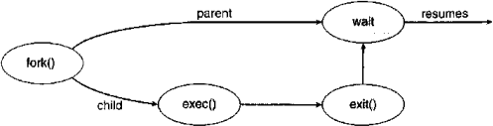

Figure 3.11 Process creation.

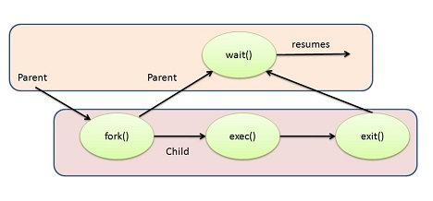

he fork() system call creates a new child process by duplicating the parent process. A new Process Control Block (PCB) is created for the child, which is initially a copy of the parent’s PCB. However, the child has a unique PID and executes independently of the parent.

Parent Process has:
- Code (program instructions)
- Data (variables)
- Heap (dynamic memory)
- Stack (function calls)
- PCB (process info)

After fork()
Parent (PID = 100)
|
| fork()
↓
Child (PID = 101)
👉 OS creates:
- New PCB (child)
- New memory space (child)
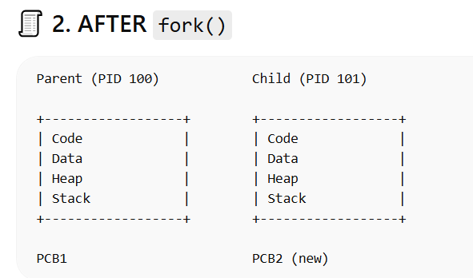
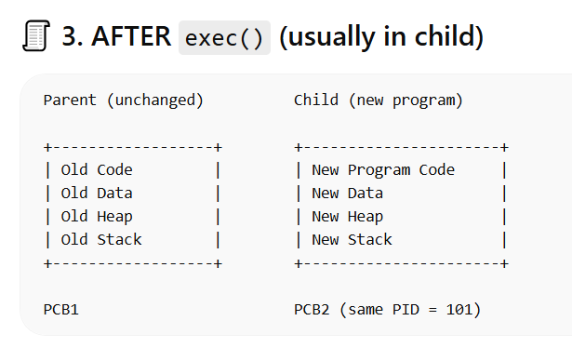
- A parent process creates a sub process by making a fork() system call.
- After the fork(), exec() system call is used to load the binary file of child process into memory and start its execution.
- While the child process is executed, the parent process can create more children. If parent process has nothing to do, it just issues the wait() system call and waits until the child processes exit.
- exit() system call terminates the process. When it is used on the child process, it exists and parent is notified to resume
Feature | 🐧 UNIX / Linux | 🪟 Windows
First Process | init / systemd (PID = 1) | No single root; starts with System + smss.exe
Process Creation | fork() | CreateProcess()
Program Execution | exec() | Built into CreateProcess()
Steps | Two-step: fork + exec | One-step
Process Type | Child is duplicate first | Direct new process
Process ID | PID (integer) | Process ID (handle-based)
Parent–Child Relation | Strong hierarchy (process tree) | Exists but less strict
Waiting Mechanism | wait() | WaitForSingleObject() / WaitForMultipleObjects()
Purpose of wait | Parent waits for child termination & gets status | Parent waits for process handle to signal completion
Zombie Process | Yes (if no wait()) | No zombies (handled differently)
Orphan Process | Adopted by init | Handled by OS (no strict adoption like init)
Memory Handling | Copy-on-Write after fork | Separate memory spaces
Flexibility | High (separate fork & exec) | Less flexible but simpler

Operation - Process Creation - fork() System Call
The process can create the new process by using the fork() system call. The creating process is known as parent process whereas the newly created process is known as child process.

Process ID
In general, each process has a unique process identification number called process id(i.e pid). Most of the operating system use this pid to identify the process.

Required Resources
Usually the process requires some resources (CPU time, file, memory, I/O device) to complete its task. When a process creates several new processes, that child processes may able to get its resources from operating system. That means, the parent process may assign some resources to its children or it may have to share some resources with its children.

Process Address Space
In terms of address space, There are also two possibilities:
- The child process is a duplicate of the parent process that means, the child has the same program and data as the parent.
Without exec()
Parent → fork() → Child (same program)
- The child process has a new program loaded into it.
With exec()
Parent → fork() → Child → exec() → New program

Operation - Process Execution - exec() System Call
When a process creates a new process, then there are two possibilities in terms of execution:
- The parent process continues to execute concurrently with its children.
- The parent process waits until some or all of its children have terminated.
exec() system call is used to load the binary file of child process into memory and start its execution.

Operation - Process Blocking - wait() System Call
wait() system call is called to make a process wait until something else happens. The wait() system call is used by the parent process to wait for the termination of its child process. It is independent of whether the child uses exec() or not, as it only depends on the existence and completion of the child process.

Operation - Process Termination - exit() System call
The exit() system call is used to terminate the process. Once the process completes its execution of final statement, it asks the operating system to delete the process from memory and deallocates its all resources. After the termination, the child may return their status code to its parent.
Parent may terminate their children due to the following reasons:
- The child has exceeded its usage of some of the resources that it has been allocated.
- The work assigned to the child is no longer required
- If the parent terminates, the operating system may not allow a child to continue its execution.

The following Code :
- Process creation in Windows using CreateProcess()
- Parent–child relationship
- Waiting for child using WaitForSingleObject()

#include <stdio.h>
#include <windows.h> int main(VOID)
{
STARTUPINFO si;

PROCESS_INFORMATION pi;
// allocate memory ZeroMemory(&si, sizeof (si)) ; si.cb = sizeof (si) ; ZeroMemory(&pi, sizeof(pi));
// create child process
if (!CreateProcess(NULL, // use command line "C:\\WINDOWS\\system32\\mspaint.exe", // command line NULL, // don't inherit process handle
NULL, // don't inherit thread handle FALSE, // disable handle inheritance 0, //no creation flags
NULL, // use parent's environment block NULL, // use parent's existing directory &si, &pi))
{
fprintf(stderr, "Create Process Failed"); return -1;
}
// parent will wait for the child to complete WaitForSingleObject(pi.hProcess, INFINITE); printf("Child Complete");
// close handles CloseHandle(pi.hProcess); CloseHandle(pi.hThread);
}

Figure 3.12 Creating a separate process using the Win32 API.

In Windows, CreateProcess() uses two structures: STARTUPINFO and PROCESS_INFORMATION. STARTUPINFO defines properties like window size, appearance, and I/O file handles, while PROCESS_INFORMATION holds the handle and IDs of the new process and its thread. Memory for these structures is allocated using ZeroMemory() before calling CreateProcess().
The first two parameters of CreateProcess() are the application name and command line parameters. If the application name is NULL, the command line specifies the application to load (e.g., mspaint.exe). Default settings are used for inheriting handles, creation flags, environment block, and starting directory. The pointers to the STARTUPINFO and PROCESS_INFORMATION structures are also passed.
The parent process waits for the child to complete using WaitForSingleObject(), which monitors the child's handle (pi.hProcess). Once the child process exits, control returns to the parent.
    - Process Termination
A process terminates when it finishes execution and calls the exit() system call. It may return a status to its parent process via wait(). The operating system deallocates all resources of the process. Termination can also occur if one process terminates another using system calls, usually by the parent process. A parent can terminate a child for reasons such as resource overuse, task completion, or the parent’s own termination. Some systems, like VMS, enforce cascading termination, where if a parent process terminates, all its children are also terminated.
In UNIX, a process can be terminated using the exit() system call. The parent can wait for the termination of a child using wait(), which returns the child’s process ID. If the parent terminates, its children are reassigned to the init process, ensuring they still have a parent to collect their status and execution data.

A process terminates when it completes execution of its final statement and calls the exit() system call. At termination, the process may return a status value (usually an integer) to its parent, which can be collected using the wait() system call. The operating system then deallocates all resources of the process, including memory, open files, and I/O buffers.

🔄 Other Ways of Termination
A process can also be terminated by another process using system calls (e.g., TerminateProcess() in Windows). However, this is usually allowed only for the parent process to prevent unauthorized termination. Therefore, when a child is created, its identity (PID) is passed to the parent.

📌 Reasons for Parent Terminating Child
- Child exceeds allocated resources
- Task assigned to child is no longer needed
- Parent itself is terminating

⚠️ Cascading Termination
In some systems, if a parent process terminates, all its child processes are also terminated automatically. This is called cascading termination and is handled by the operating system.

⚙️ System Calls
- exit(status) → terminates process and returns status
- wait() → parent waits for child to finish and collects status

🧠 Key Points
- exit() → ends process + releases resources
- wait() → parent collects child’s result
- Parent can control child processes
- OS ensures proper cleanup

Zombie Process
- When a child process terminates:
  - Its resources are freed
  - But its process table entry remains (to store exit status)
- This state is called a zombie process
- It exists until the parent calls wait()
- After wait(), the zombie is completely removed

👶 Orphan Process
- If the parent does not call wait() and terminates:
  - Child becomes an orphan process
- In UNIX/Linux:
  - Orphan is adopted by init (PID = 1)
  - init calls wait() and cleans it up

🧠 Key Points
- wait() → collects child status + removes zombie
- Zombie → terminated but not yet cleaned
- Orphan → running child without parent
- init → adopts and cleans orphans
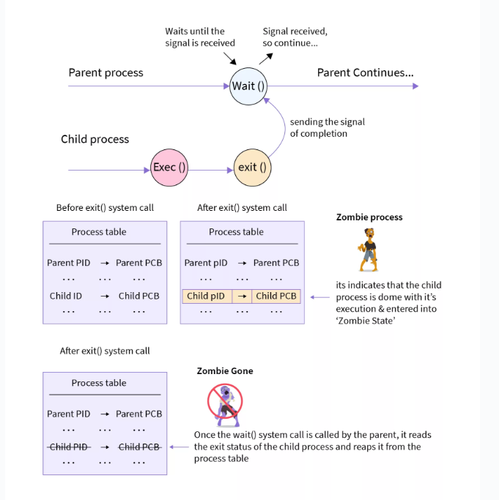
OPHAN
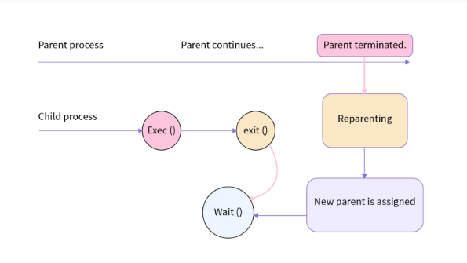

3.4 Interprocess Communication
  - Independent Processes operating concurrently on a systems are those that can neither affect other processes or be affected by other processes.
  - Cooperating Processes are those that can affect or be affected by other processes. There are several reasons why cooperating processes are allowed:
    - Information Sharing - There may be several processes which need access to the same file for example. ( e.g. pipelines. )
    - Computation speedup - Often a solution to a problem can be solved faster if the problem can be broken down into sub-tasks to be solved simultaneously ( particularly when multiple processors are involved. )
    - Modularity - The most efficient architecture may be to break a system down into cooperating modules. ( E.g. databases with a client-server architecture. )
    - Convenience - Even a single user may be multi-tasking, such as editing, compiling, printing, and running the same code in different windows.

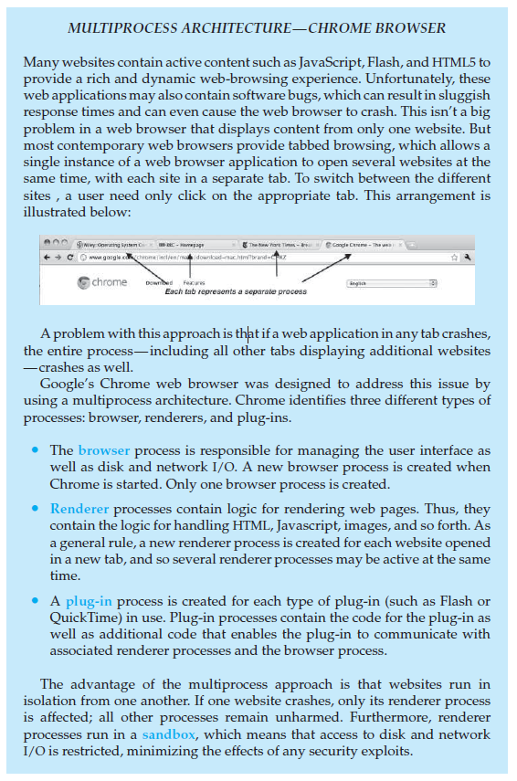

- Cooperating processes require some type of inter-process communication, which is most commonly one of two types: Shared Memory systems or Message Passing systems. Figure 3.12 illustrates the difference between the two systems:
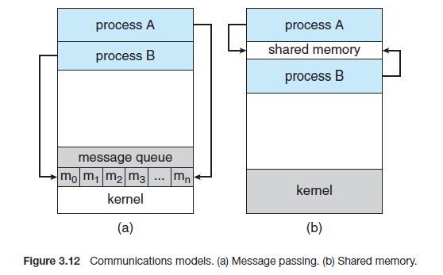
- Shared Memory is faster once it is set up, because no system calls are required and access occurs at normal memory speeds. However, it is more complicated to set up, and doesn't work as well across multiple computers. Shared memory is generally preferable when large amounts of information must be shared quickly on the same computer.
- Message Passing requires system calls for every message transfer, and is therefore slower, but it is simpler to set up and works well across multiple computers. Message passing is generally preferable when the amount and/or frequency of data transfers is small, or when multiple computers are involved.

3.4.1 Shared-Memory Systems
- In general, the memory to be shared in a shared-memory system is initially within the address space of a particular process, which needs to make system calls in order to make that memory publicly available to one or more other processes.
- Other processes which wish to use the shared memory must then make their own system calls to attach the shared memory area onto their address space.
- Generally, a few messages must be passed back and forth between the cooperating processes first in order to set up and coordinate the shared memory access.

Producer-Consumer Example Using Shared Memory
- This is a classic example, in which one process is producing data and another process is consuming the data. ( In this example in the order in which it is produced, although that could vary. )
- The data is passed via an intermediary buffer, which may be either unbounded or bounded. With a bounded buffer the producer may have to wait until there is space available in the buffer, but with an unbounded buffer the producer will never need to wait. The consumer may need to wait in either case until there is data available.
- This example uses shared memory and a circular queue. Note in the code below that only the producer changes "in", and only the consumer changes "out", and that they can never be accessing the same array location at the same time.

Given the common fixed-size buffer, the task is to make sure that the producer can't add data into the buffer when it is full and the consumer can't remove data from an empty buffer. Accessing memory buffers should not be allowed to producers and consumers at the same time.
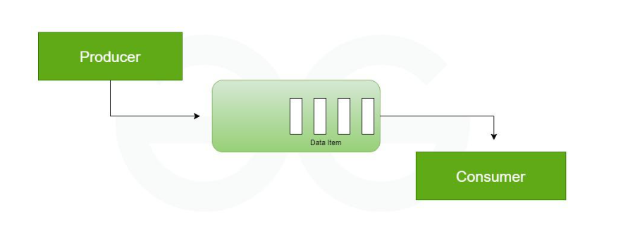
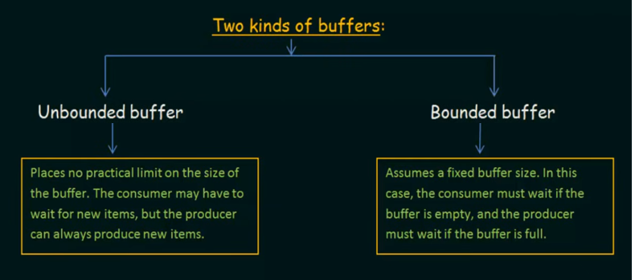

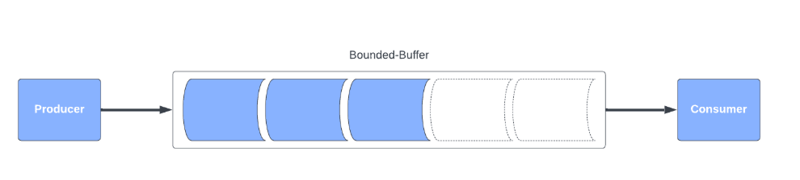

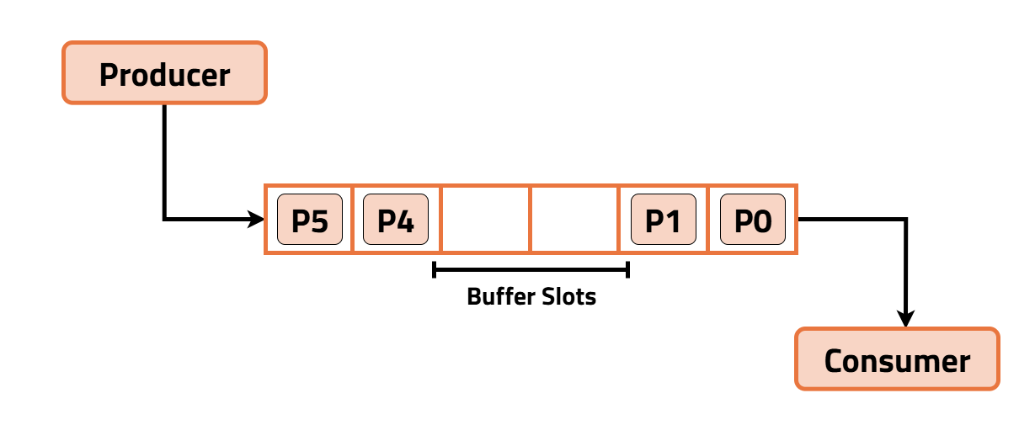

This code implements the producer-consumer problem using shared memory and a circular buffer. The producer inserts items into the buffer when space is available, and the consumer removes items when available. Synchronization is handled using busy waiting, checking conditions for full and empty buffer.
- First the following data is set up in the shared memory area:
#define BUFFER_SIZE 10
typedef struct {
. . .
} item;
item buffer[ BUFFER_SIZE ];
int in = 0;
int out = 0;
- Then the producer process. Note that the buffer is full when "in" is one less than "out" in a circular sense:
// Code from Figure 3.13
item nextProduced;
while( true ) {
/* Produce an item and store it in nextProduced */
nextProduced = makeNewItem( . . . );
/* Wait for space to become available */
while( ( ( in + 1 ) % BUFFER_SIZE ) == out )
; /* Do nothing */
/* And then store the item and repeat the loop. */
buffer[ in ] = nextProduced;
in = ( in + 1 ) % BUFFER_SIZE;
}
- Then the consumer process. Note that the buffer is empty when "in" is equal to "out":
// Code from Figure 3.14
item nextConsumed;
while( true ) {
/* Wait for an item to become available */
while( in == out )
; /* Do nothing */
/* Get the next available item */
nextConsumed = buffer[ out ];
out = ( out + 1 ) % BUFFER_SIZE;
/* Consume the item in nextConsumed
( Do something with it ) */
}

3.4.2 Message-Passing Systems

Message Passing

│

├── Operations

│ ├── send()

│ └── receive()

│

└── Key Issues

│

├── 1. Naming

│ ├── Direct

│ │ ├── Symmetric

│ │ └── Asymmetric

│ └── Indirect (Mailbox)

│

├── 2. Synchronization

│ ├── Blocking

│ └── Non-blocking

│

└── 3. Buffering

├── Zero

├── Bounded

└── Unbounded

Message Passing in Interprocess Communication

Message Passing (IPC)
│
├── Definition
│ └── Communication via send() & receive()
│ (No shared memory)
│
├── Purpose
│ ├── Communication
│ ├── Coordination
│ └── Synchronization
│
├── Why Needed
│ ├── Shared Memory
│ │ ├── Needs shared space
│ │ └── Programmer manages access
│ │
│ └── Message Passing
│ ├── OS manages communication
│ └── No shared address space
│
├── Main Advantage
│ ├── Works in distributed systems
│ └── Processes on different machines
│
├── Operations
│ ├── send(message)
│ └── receive(message)
│
├── Message Size
│ ├── Fixed
│ │ ├── Simple
│ │ └── Less flexible
│ │
│ └── Variable
│ ├── Flexible
│ └── Complex
│
├── Trade-off
│ └── Simple system ↔ Easy programming
│
└── Requirement
└── Communication Link between processes

Meaning
Message passing is a method of Interprocess Communication (IPC) in which processes communicate by sending and receiving messages.
It allows processes to:
- communicate
- coordinate
- synchronize their actions
without sharing the same address space.

Why Message Passing is Needed
In a shared-memory environment:
- processes must share a memory region
- the programmer must explicitly write code to access and manage that shared memory
In message passing:
- the operating system provides the communication facility
- processes exchange messages instead of directly sharing memory
So, message passing is easier to manage in many situations, especially when processes are on different systems.

Main Advantage
Message passing is especially useful in a distributed environment, where:
- processes may run on different computers
- the computers are connected through a network
Example
An Internet chat program:
- users communicate by exchanging messages
- each participant may be on a different machine

Basic Operations in Message Passing
A message-passing system provides at least two operations:
- send(message)
- receive(message)
Meaning
- send(message) → a process sends a message
- receive(message) → a process receives a message

Message Size
Messages can be of two types:
1. Fixed-size messages
Advantages
- system implementation is simple
- easier for OS to manage
Disadvantages
- programming becomes difficult
- not flexible

2. Variable-size messages
Advantages
- programming becomes easier
- more flexible
Disadvantages
- OS implementation becomes more complex

Trade-off
This shows a common operating-system trade-off:
- simple system design ↔ difficult programming
- complex system design ↔ easy programming

Requirement for Communication
If two processes, say P and Q, want to communicate:
- P must send messages to Q
- Q must receive messages from P
- a communication link must exist between them

Logical Ways to Implement Communication Link
The communication link can be logically designed in different ways:
1. Direct or Indirect Communication
Direct Communication
- sender sends directly to receiver
- receiver gets directly from sender
Indirect Communication
- messages are sent through an intermediate object like a mailbox or port

2. Synchronous or Asynchronous Communication
Synchronous Communication
- sender or receiver may have to wait
- also called blocking communication
Asynchronous Communication
- sender or receiver does not wait
- also called non-blocking communication

3. Automatic or Explicit Buffering
Automatic Buffering
- buffer management is handled automatically by the system
Explicit Buffering
- programmer or process must handle the buffer explicitly

Naming → creates link
Buffering → stores messages
Synchronization → controls waiting

In message passing IPC, naming determines the communicating processes, synchronization controls whether processes wait during communication, and buffering defines how messages are stored. Buffering directly influences synchronization behavior, while naming establishes the communication link.

3.4.2.1 Naming

In direct communication, processes explicitly name each other using send() and receive() primitives, leading to tight coupling and reduced modularity. In indirect communication, messages are exchanged through mailboxes or ports, allowing multiple processes to communicate flexibly without knowing each other’s identity. Mailboxes can be owned either by processes or by the operating system

Direct = name the process

Indirect = use a mailbox
1. Direct Communication
Processes explicitly name each other
- Symmetric addressing
  - send(P, message) / receive(Q, message)
  - Both sides must name the other
- Asymmetric addressing
  - send(P, message) / receive(id, message)
  - Only sender names the recipient; id set automatically
- Link: automatic, exactly 2 processes, one link per pair
- Drawback: limited modularity — hard-coded process IDs
2. Indirect Communication (Mailboxes / Ports)
- Messages go through shared mailboxes
  - send(A, message) / receive(A, message)
- Link: requires shared mailbox, can involve >2 processes, multiple links per pair
- Shared mailbox — who receives?
  - Limit link to 2 processes
  - Allow only one receive() at a time
  - System selects (e.g., round robin)
- Mailbox ownership
  - Process-owned → owner receives, users send; dies with process
  - OS-owned → independent; create / send / receive / delete; ownership transferable

3.4.2.2 Synchronization

In message passing, communication can be blocking (synchronous) or non-blocking (asynchronous). In blocking communication, the sender or receiver waits until the message is delivered or received. In non-blocking communication, processes continue execution without waiting. When both send() and receive() are blocking, a rendezvous occurs, ensuring synchronization between processes.

Blocking = wait Non-blocking = continue
- Blocking (synchronous)
  - Blocking send → waits until received
  - Blocking receive → waits until message available
  - Both blocking = rendezvous → trivially solves producer–consumer
- Nonblocking (asynchronous)
  - Nonblocking send → continues immediately
  - Nonblocking receive → returns message or null

3.4.2.3 Buffering
Message queue capacity determines how messages are stored temporarily during interprocess communication. There are three types of message queue capacities based on buffering.
• Zero Capacity: No buffer; sender must wait until the receiver accepts the message.
• Bounded Capacity: Limited buffer (size n); sender waits only if the queue is full.
• Unbounded Capacity: Infinite buffer; sender never waits as messages are always stored.
In zero capacity (no buffering), the queue size is zero, meaning no message can be stored in the queue. Therefore, the sender must wait until the receiver is ready to accept the message. The sender is always blocked, and the receiver must immediately receive the message. This leads to strict synchronization between sender and receiver and is similar to the rendezvous concept, where both processes must be ready at the same time.
In bounded capacity (finite buffering), the queue has a fixed size of n. Messages can be stored in the queue up to this limit. If the queue is not full, the message is placed in the queue and the sender continues execution without waiting. However, if the queue becomes full, the sender is blocked until space becomes available. Thus, blocking occurs only when the buffer is full, providing partial synchronization.
In unbounded capacity (infinite buffering), the queue size is considered infinite, allowing any number of messages to be stored. The sender never blocks, as there is always space available in the queue. This enables completely asynchronous communication between processes.

Category | 🔴 Shared Memory Applications | Message Passing Applications
Communication Type | Same system, high-speed | Distributed / network-based
Example Systems | Producer–Consumer buffer | Client–Server systems
Real-time Systems | Video streaming, gaming | Chat, messaging apps
Computing | Parallel processing, simulations | Distributed computing
Data Handling | Databases, shared cache | Microservices communication
OS Usage | Multithreading (shared data) | Inter-process communication across OS
Performance | High speed (direct access) | Slower but safer
Security | Less secure (shared access) | More secure (no shared memory)

